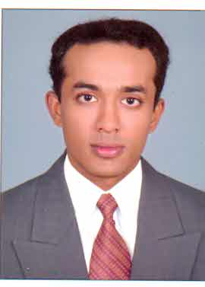
CURRICULUM VITAE
OF
sarath gopal
CHANDRIKA, VP-3/1203, Kaattuvila,
Peyadu P.O, Trivandrum, Kerala, Pin-695573
E-mail : sarathgopaltvm@gmail.com
Mob- +91 9943483804

Objective: To be inducted in an esteemed organization and to improve continually in the field with utmost sincerity and energy and to be the most preferred individual as a friend who is always behind innovative suggestions.
Professional Experience
* Currently working as a F&B Supervisor at Hotel Le Pondy, Pondicherry, India, From Feb-02-2014 to till date
* Worked as an F&B Associate in Hotel Park Plaza, a Carlson group hotels
Bangalore, India from April-18-2011 till January-13-2012.
* Two years of experience in F & B service at Elite Resort & Spa, Bahrain.
* One Year Apprenticeship in F & B Service at Le Meridien, Cochin, India.
* One Year Industrial Training in F & B Service at Le Meridien, Cochin, India.
* Three months experience in PIZZA CORNER, by Oberon,Trivandrum, India

* Experience in in-door and out-door Caterings.

Professional Qualification
* One Year Diploma in Hotel and Catering Technology from Academy for Management Studies, Trivandrum

Academic Qualification

* Pre Degree in Bachelor of Science & Commerce (two years)

Personal Information

Date of Birth : 30- Sep-1987
Sex : Male
Marital Status : Single

Languages Known

English, Malayalam (Mother tongue). Hindi, Tamil

Passport Details :

Passport No. : F 9130448
Place of Issue : Trivandrum
Nationality : Indian
Date of Issue : 17-10-2006
Date of Expiry : 16-10-2016

Reference

Mr. Arun Raghavan
General Manager,
Hotel Le Pondy, Pondicherry, India.
Ph: +91-9585551301

Mr. Jibin Thomas
Restaurant Manager,
Hotel Le Pondy, Pondicherry, India.
Ph: +91-9585551317

Mr Pradeep Kumar,
Bar Manager,
Park Plaza, Bangalore, India
Ph: +91-9980668127

DECLARATION

I HEREBY CONFIRM THAT THE INFORMATION GIVEN ABOVE IS TRUE TO THE BEST OF MY KNOWLEDGE AND BELIEF

SARATH GOPAL C.V
Place: Kerala, India

