Jeninmon James
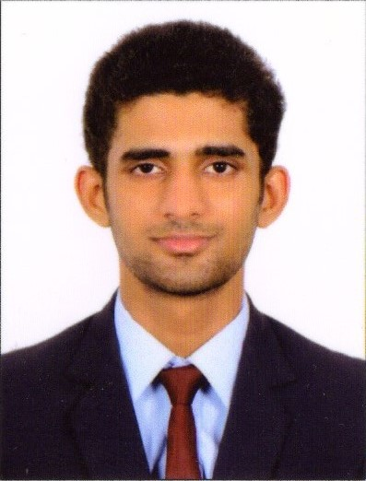
Chettukuzhiyil(H)
Mankulam po
Anakulam
Idukki 685565
Mobile:9496181176
Email ID:JeninJames25@gmail.com

OBJECTIVE
I am self-motivated and result oriented person who believes in achieving my goals through rigorous efforts.To be a part of an organization where I can utilize my skills and leadership abilities in the most proficient manner and gather knowledge to build my career.
PERSONAL DETAILS
Name :Jeninmon James
Date of birth :11-07-1997
Father name :James c c
Permanent Address :Chettukuzhiyil(H)
Mankulam po
Anakulam
Idukki 685565
Gender :male
Marital status :single
Religion :Christian
Contact No :9496181176

PERSONAL STRENGTH
Committed towards work
Service oriented
Self confident
Hard worker

LANGUAGES KNOWN
Malayalam :speak,write&read
English :speak,write&read
QUALIFICATIONS | MONTH&YEAR | INSTITUTION
SSLC | MARCH 2013 | ST MARYS HIGHER SECONDARY MANKULAM
PLUS TWO | MARCH 2015 | GVHSS THODUPUZHA
DIPLOMA IN AVIATION | JULY 2016 | FRANKFINN INSTITUTE OF AIR HOSTESS TRAINING

HEIGHT&WEIGHT

HEIGHT:-175cm
WEIGHT:-60kg

WORK EXPERIENCE
6 months work experience in Taj India Tours as a air ticketing executive in Trivandrum domestic airport from SEP 2016 to FEB 2017.

DECLARATION
I hereby declare that the statement made above are true,complete & correct to the best of my knowledge & belief.
Place: JeninmonJames
Date :

