**RESUME**

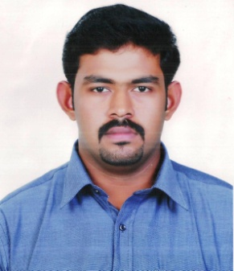

**KEVIN JAMES**

Purackal House, Niranam P.O,   
Thiruvalla, Pathanamthitta, 689621

Phone Number: +919447797982

Email id: [kevinpurackal@yahoo.com](mailto:kevinpurackal@yahoo.com)

JOB OBJECTIVE

I am a recent college graduate seeking a position that will allow me to use my Bachelor of Business Administration, my practical experience as well as my eagerness to contribute to the organisation.

EDUCATIONAL QUALIFICATION

* Degree in Bachelor of Business Administration,

Girideepam Institute of Advanced Learning, Kottayam 2012-2015

* Web Technology

Government Engineering College, Barton Hill, Trivandrum 2011

* Higher Secondary

Christ Nagar English Higher Secondary School, Trivandrum 2011

* High School

Christ Nagar English Higher Secondary School, Trivandrum 2009

SKILLS AND KNOWLEDGE

* Good Computer Knowledge (MS Office, Photoshop, Movie Maker)
* Good Communication skill
* Leadership Skill
* Team Player
* Administration Skill

AWARDS AND ACHIEVEMENTS

* Project work done on HR in Deedi Motors Pvt. Ltd.
* Acted as General Secretary of the Students Union in Girideepam Institute of Advanced Learning
* Acted as the Secretary of BBA Association in Girideepam Institute of Advanced Learning
* Event convener of the Management Fest GEMS’14 conducted in GIAL
* Volunteer in-charge of Sargasangamam CBSE School Youth Festival 2013 in Kottayam
* Student House Captain in Christ Nagar School

PERSONAL DETAILS

Name : Kevin James

Date of Birth : 04 Nov 1993

Sex : Male

Father’s Name : James P Abraham

Mother’s Name : Ivy James

Address : Purackal House Niranam P.O, Thiruvalla, 689621

Languages Known : English, Malayalam, and French

REFERENCE

* Mrs. Treasa Fyna

Head of the Department, BBA

Girideepam Institute of Advanced Learning, Kottayam

* Mr. Sailesh Nair

Placement Officer,

Girideepam Institute of Advanced Learning

DECLARATION

I, Kevin James, here by certify that the above mentioned details are true to the best of my knowledge and virtue. I hope that you will find my credentials suitable and consider me for interview.

Yours Sincerely,

Date : Kevin James

Place : Trivandrum