CURRICULUM VITAE

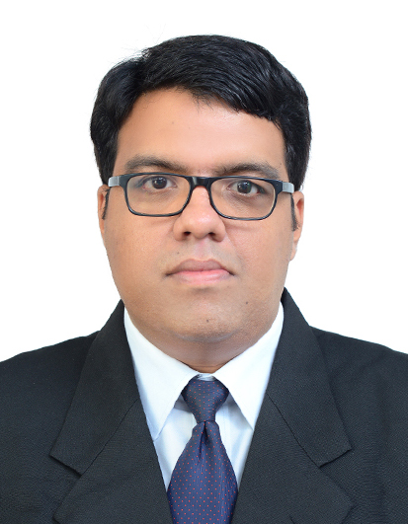
SURAJ .S
Address T.C 19/2279(3), Harivasaram (H), Poojapura P.O Chengallor graderns,
Trivandrum (Dist), Kerala
Pin: 695012
Contact: +919746778807 / 0471-2353909
E-mail: suraj.s009@gmail.com

Career Objective:

I wish to exploit my talent to grow with the Organization and to become a responsible person by doing hard work. I am confident that I could deliver my best for the betterment of the organization.

Educational qualification:
Qualification | University / board | Year of completion | Grade/ %
FOOD CRAFT INSTITUTE (RECEPTION COURSE) | Kerala State TECH | 2012 | 67
DIPOLMA IN HOTEL MANAGEMENT (KITCO) | KERALA | 2008 | 60
PLUS TWO | BHSE | 2010 | 60
SSLC | Kerala | 2005 | 55

Working Experience:
- Has worked as reception trainee at Hotel Samudra (KTDC),on 2008-2009
- Has worked as reception trainee at Hotel Chaithram (KTDC) ,on 2009-2013

Technical skills:
- Check -In Check -Out process
- Key handling
- Telephonic conversation
- Handling Reservation
- Problem Solver
- Salesmanship

Languages skills:
- English
- Malayalam

PERSONAL DATA

Name: Suraj .s
Sex: Male
Blood Group: O +ve
Date of Birth: 14nd April 1987
Father: Suresh .G
Mother: Geetha Suresh
Familiar language: English, Malayalam

DECLARATION

I hereby declare that the above information furnished by me are true and correct.

SURAJ.S

