VYSAKHAN.S  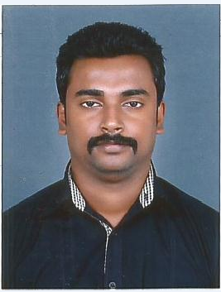  Mobile: 9995356205  Email:vyshu46@yahoo.com  Languages Known :  - English  - Tamil  - Hindi  - Malayalam  Competencies  - Good coordinator  - Pleasing attitude  - Good team player  - Cope up with any situation | Career Objective  To be part of an organization which uses my skills and expertise in the field of Human Resources for the growth and change of the organization while giving me opportunities to learn and enrich my competencies.  Work Experience  Organization : Spericorn Technology Pvt Ltd  Designation : HR Executive  Duration : 20 October 2014 – 3 November 2015  Responsibilities  - Manage Full spectrum of HR & Admin functions.  - Extensive knowledge of Payroll reconciliation, tracking and reporting.  - Daily Attendance Management System and Leave management.  - Handling statutory activities PF, ESIC, Professional Tax etc.  - Recruitment and Joining Formalities  - Exit Formalities  - Maintaining good internal communication within the company.  - Coordination and Formulation of the Appraisal Process  - Policy Formulation and implementation  - Developing various reports for management which make it easy to make decisions regarding the current resources.  Organization : Aptara Learning Pvt Ltd  Designation : Quality Analyst  Duration : 4 April 2012- 15 October 2014  Responsibilities  - Proofing the financial statements and E books through online.  - Checking the customer requirements and needs.  - Handled both Quality Analyst Team and Proof Reading.
Hobbies  - Biking  - Traveling  - Films & Songs  - Reading  Personal Details  Date of Birth : 19-07-1989  Sex : Male  Marital Status : Married  Permanent Address :  TC 41/32, Puthen Veedu Manacadu P.O, Thiruvanathapuram 695009 | Educational Development  - PG MBA( in HR ) under Annamalai University [65%] 2011-2013  - Degree in B.Sc Computer Science under Kerala University [63%]  (MARTHOMA College of Science and Technology ,2007-2010)  Declaration  I will be very much privileged to work with you and will substantiate my claims to the best of my ability if given a chance. Looking forward for a chance to prove my abilities.  - Vysakhan.S

