**RESUME**

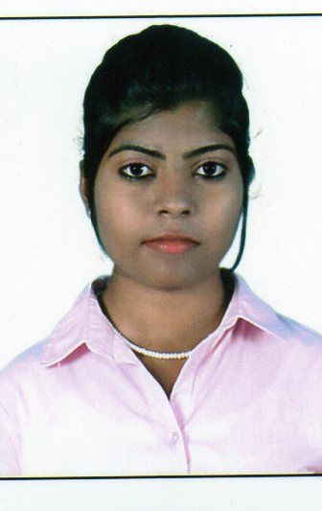

Freji Mol B.K

**Contact number:-**

**8129435536**

**Email:-**

[**freji93@gmail.com**](mailto:freji93@gmail.com)

**Freji Mol B.K**

**Fredy Cottage,**

**Chemboor,**

**Ottasekharamangalam P.O**

**Trivandrum,Kerala**

**PIN-695125**

**Email** [**–freji93@gmail.com**](mailto:–freji93@gmail.com)

**CAREER OBJECTIVE**

To establish myself as a front runner in the field of Hospitality industry & to increase my expertise and experience in Hotel Operations.

**GENERAL QUALIFICATION**

* Self motivated, enthusiastic to learn, resourceful and well

Organized, good team player.

* Can handle multiple tasks, result driven and work under

pressure with minimum supervision.

* Knowledge about Tally, M.S Office, M.S Excel.
* Knowledge about Hotel Room Reservation, Air Ticketing and

Fare calculation.

**ACADEMIC QUALIFICATION**

* SSLC
* Higher Secondary

**PROFESSIONAL QUALIFICATION**

* Diploma in Airline Passenger Service
* Galileo CRS Basic Course

**WORK EXPERIENCE**

01/07/2015 to Current **GREEN TRENDS HAIR & STYLE SALON as MANAGER**

***R***

***E***

***S***

***U***

***M***

***E***

**Responsibilities**

* Managed front office area, including greeting and responding to

telephone and in-person requests for information

* Handle all conditions such as solve customers’ inquiries, provide

customer requirement etc.

* Responsible for checking the grooming of the staff members and

trainees.

* Helped to carry daily process to increase the speed of total work.
* Completed all cash related activities on required date.

**STRENGHTS**

* Team Player
* Honest
* Flexible
* Optimistic

**HOBBIES**

* Travelling
* Dancing
* Reading Books

**PERSONAL INFORMATION**

Name : Freji Mol B.K

Father’s Name : B. Kuttappan

Mother’s Name : R. Baby

Date of Birth : 09 May 1993

Place of Birth : Vallavilai, Tamil Nadu

Sex : Female

Marital Status : Single

***R***

***E***

***S***

***U***

***M***

***E***

Religion : Christian

Nationality : Indian

State : Kerala

City : Trivandrum

Languages known : English, Malayalam, Tamil, Hindi

**DECLARATION**

I hereby certify that the aforementioned information are true and correct to the best of my knowledge.

**Date : 09/08/2015 Freji Mol B.K**

**Place: Trivandrum**