RESUME

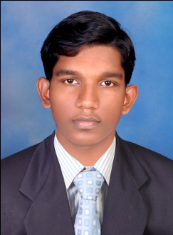

JEEVAN M.R

Mob. : 08606533268

jeevan89ravi@gmail.com

CAREER OBJECTIVE :-

Seeking a quality environment where my skill and knowledge can be shared and enriched to work in a progressive work culture with all freedom to be creative and innovative.

Seeking a challenging job in a good organization where I can widen my horizon of knowledge and experience to serve this corporate world make a sky reaching career.

EDUCATIONAL QUALIFICATION

* 3 year Aviation diploma from Nehru college of aeronautics and applied sciences, Coimbatore , India
* 6 months diploma in professional accountancy with tally and peachtree.
* 10+2 from Nandikkara govt higher secondary school, thrissur, Kerala.
* SSLC passed from Nandikkara govt high school , thrissur

SOFTWARE SKILLS :-

1. MS-Office
2. Tally 9.0
3. Peachtree
4. Photoshop

WORKING EXPERIENCE :-

* SPICE GARDEN RESTAURANT (Restaurant manager) kumily, 2012 november to till date.

NATURE OF WORK

• welcoming guests to the restaurant .

•making them feel comfortable.

•providing them beverages.

Supervising the cleanliness of the restaurant.

Controlling the cost.

Taking decisions on operational issues.

Attending phone calls to book tables.

Billing.

Cashing.

Maintaining the drinks inventory.

* ARAVIND FOOD PRODUCTS PVT LTD. Thrissur march 2011 to November 2012(sales executive)

NATURE OF WORK

• Taking orders and from retailers delivering them.

• Keeping accurate transactions and recording the details.

• Maintaining the inventory.

PERSONAL DETAILS :-

Father’s Name : Raveendran M.A

Gender : Male

Nationality : Indian

Date of Birth : 03/11/1989

Marital Status : Unmarried

Language Known : English, Hindi , Malayalam, Tamil

Hobbies : Reading, Music and learning new softwares from internet.

PERSONAL STATEMENT :-

I hereby declare the particulars given here is true to the best of my knowledge and belief.

Place :-

Date :-

( JEEVAN M.R )