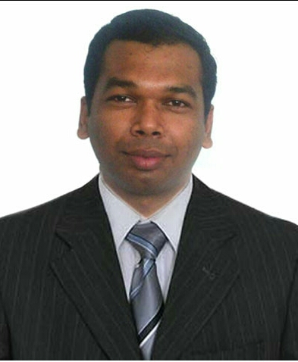
VISHNU P.T
Eswari Vilasam, TC-75/1980, Palli Road, Pettah P .O, Thiruvananthapuram-695024, Kerala, India
Contact: +918086433948; Email: vishnupt08@gmail.com
Executive Housekeeper
During an illustrious career spanning 8+ years, I have acquired wide-ranging experience in handling multiple responsibilities pertaining to housekeeping in five star hotels, restaurants. I possess demonstrated skills in:

- Implementing polices to promote & protect health, safety, security & the quality of the work life, the environment and organizational effectiveness
- Managing the financial aspects of Housekeeping functions including budgeting, inventory management, reporting, etc
- Methods of cleaning rooms and laundering, use and storage of cleaning chemicals, various equipments such as vacuums, Ability to operate the department within the budget by appropriately forecasting and scheduling staff

Professional Experience

binmajid hotels and RESORTS ,abudhabi SINCE april 2013 to august 2015 - ASST.EXECUTIVE housekeepER
- Maintaining hygienic surroundings by efficiently managing various Housekeeping activities

- Assuring that Housekeeping supervisors and staff follows established safety regulations in the use of equipment & supplies at all times. Ensure activities in compliance of legislation and regulatory requirements in the department

- Monitoring and controlling all Housekeeping supplies and equipment and maintains adequate inventory levels of particular amenities and supplies to provide a clean, safe and comfortable environment

- Maintaining the care and use of housekeeping supplies and equipment, etc. Perform regular inspections for sanitation, order, safety and proper performance of assigned duties

- Up keeping and maintenance of equipment’s and machines, scheduling of extra cleaning shift wise, maintaining the visual appearance and aesthetic décor of the hotel premises, problem resolution, job safety practices etc.

- Responsible for responding to budgetary guidelines defining all developments and efficiencies for more effective methods of operating the department

- Monitoring VIP guests and long staying guest rooms in every section

- Planning and organizing manpower and resources for the success of day to day operations; allocating duties at floor and public area in all shifts and imparting training to the new employees, monitoring their performance and reporting to General Manager

- Administering and maintaining all machines and chemicals used in HK and looking after housekeeping control desk and office

- Assuring good physical upkeep, condition of guestrooms and housekeeping equipment’s and follow up with maintenance department for repairs and maintenances

INTERNATIONAL AIRPORT, TRIVANDRUM, INDIA, from december 2011 to april 2013 Senior Housekeeping Supervisor

HOTEL WINDSOR RAJADHANI, KERALA, INDIA, January 2011-December 2011 Junior Housekeeping Supervisor

IBN BATTUTA GATE HOTEL, DUBAI, UAE, August 2010 - December 2010 Senior Room Attendant

HOTEL JAL FUJAIRAH RESORT & SPA, UAE, February 2009 - August 2010 Housekeeping Attendant

THE CHANCERY PAVILION HOTEL, BANGLORE, INDIA, July 2007 - January 2009 Housekeeping Attendant

ST MARK’S HOTEL, BANGLORE, INDIA, November 2006 - July 2007 Trainee - Housekeeping
EducationAL QUALIFICATIONS

- Diploma in hotel management: 2006 Mar ivanious college India

- Plus Two: 2005- S.M.V higher secondary school, Thiruvananthapuram

S.S.L.C:2003-St.Mary’s, higher secondary school, Thiruvananthapuram
- Diploma in Computer Application

- Proffessional diploma in computer applications and laptop servicing

Computer Proficiency: Winhms – Hotel Edition, Opera- Hotel Edition, Hot Soft - Hotel Edition
Date of birth: 17 May 1987
Languages: English, Hindi, Malayalam, Tamil
Passport No: F 8915358

REFERENCES
MR.MOHAMMED,F&B.MANAGER MR.SHIJU, HR MANAGER MR.VIJO CHACKO EXECUTIVE CHEF
BINMAJID HOTELS BINMAJID HOTELS BINMAJID HOTELS ABUDHABI, UAE ABUDHABI, UAE ABUDHABI, UAE PHONE-+971555796659 PHONE-+971569574068 PHONE-+971558797525DECLARATION
I hereby declare that the above-mentioned information is correct up to my knowledge and bear the correctness of the above-mentioned details

Place: ABUDHABI (Vishnu P.T)

Date: 01-09-15

